**Qtext:-**

**ZedX  Shipping Corp**needs a database for its world-wide package delivery company (e.g., like  DHL or FedEX). The database must be able to keep track of customers (who ship items) and customers (who receive items); some customers may do both. Each package must be identifiable and trackable, so the database must be able to store the location of the package and its history of locations. Locations include trucks, planes, airports, and warehouses.  
a. Design an ER model for Package delivery system.        **3  marks**  
b. Identify the type of relationship between the tables.            **3 marks**  
c. Design some attributes for the  tables if need be      **2 marks  
hint:** All your attributes must be reasonable

**Qtext:-**

Convert the ER to relational schemas.  
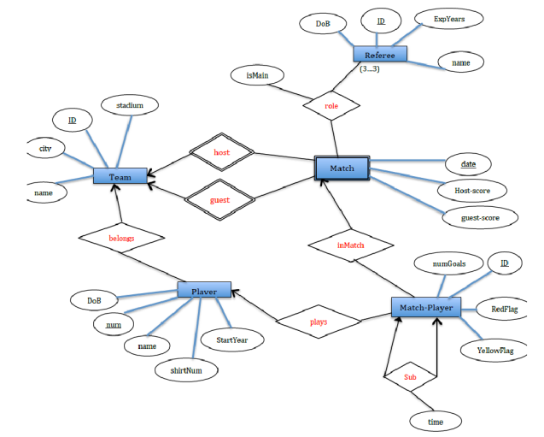**Grading:**  
Entities, attributes and PK:             **3 marks**  
Relationship:                                       **4 marks**  
Referential Integrity Constraints:   **3 marks**                   **Total marks : 10 marks**

**Qtext:-**

Consider the following relations schemas and write the **Relational Algebraic expression.**

***Suppliers (****sid: integer, sname: string, address: string****)  
Parts (****pid: integer, pname: string, color: string****)  
Catalog (****sid: integer, pid: integer, cost: real****)***

a. Find the sids of suppliers who supply every red part or supply every green part.   (1 **marks)**  
b. Find pairs of sids such that the supplier with the first sid charges more for some part than the supplier with the second sid. (1 **marks)**  
c. Find the pids of parts that are supplied by at least two different suppliers.              (1 **marks)**  
d. Find the pids of the most expensive parts supplied by suppliers named ?Khaadhigram?. (1 **marks)**  
e. Find the pids of parts supplied by every supplier at less than $200. (If any supplier either does not supply the part or charges more than $200 for it, the part is not selected.).         (1 **marks)**  
f. Find the sids of suppliers who supply some red part or are at 221 Packer Ave.      (1 **marks)**

**Qtext:-**

Consider the following relations: ***Flights (****flno: integer, from: string, to: string, distance: integer, departs: time, arrives: time, price: integer****) Aircraft****(aid: integer, aname: string, cruisingrange: integer****)  
Certified (****eid: integer, aid: integer****)  
Employees (****eid: integer, ename: string, salary: integer****).***  
Write the following queries **in SQL**. No duplicates should be printed in any of the answers.

a. For each pilot who is certified for more than three aircraft, find the eid and the maximum cruising range of the aircraft that he (or she) is certified for.                      **1 marks**  
b. Find the names of pilots whose salary is less than the price of the cheapest route from Los Angeles to Honolulu.                **1 marks**  
c. For all aircraft with cruising range over 1,000 miles, find the name of the aircraft and the average salary of all pilots certified for this aircraft.                  **1 marks**  
d. Find the names of pilots certified for some Boeing aircraft.             **1 marks**  
e. Find the aids of all aircraft that can be used on routes from Los Angeles to Chicago.        **1 marks**  
Identify the flights that can be piloted by every pilot who makes more than $100,000. (Hint: The pilot must be certified for at least one plane with a sufficiently large cruising range.)